**Task 11: Compiling Maven in local server via Jenkins Source Code Management Configuration & Trigger the Build Using Poll SCM Build Trigger**

1. **The Maven project folder got generated in the local server**

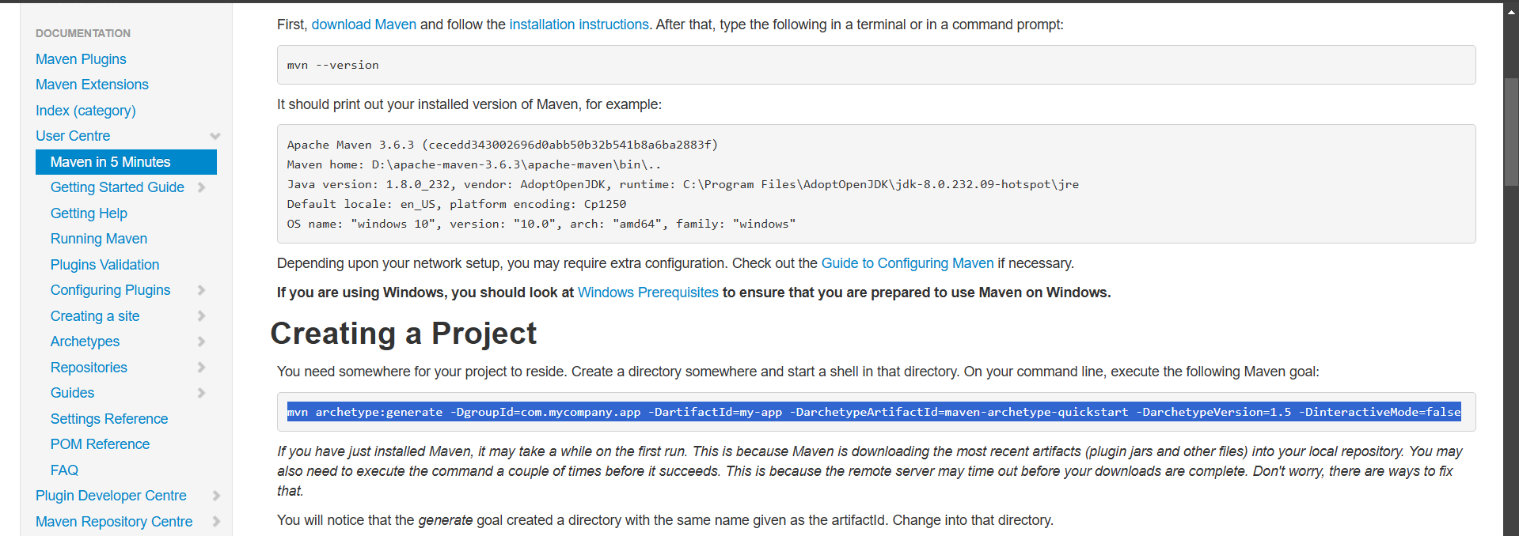

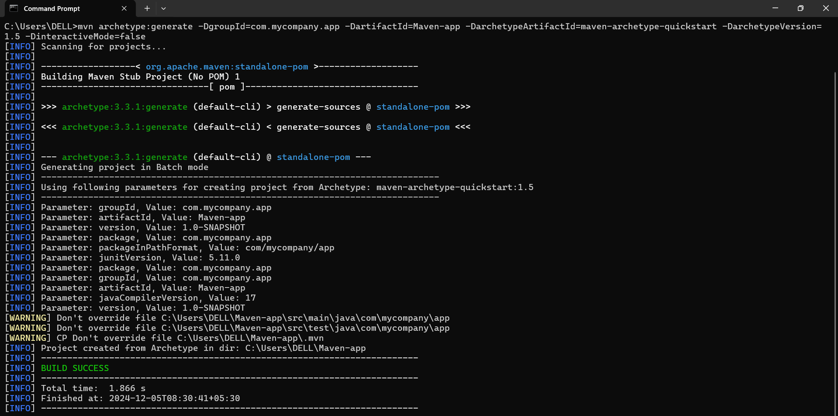

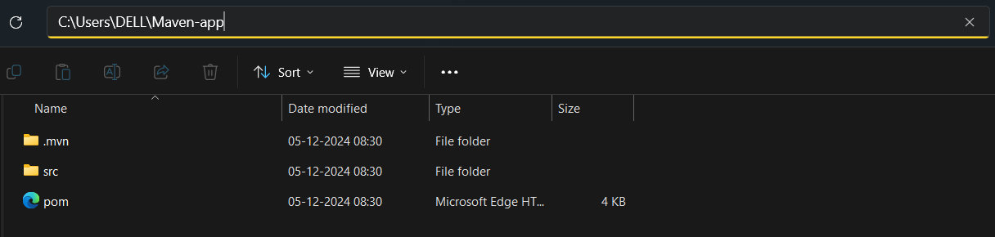

1. **The Source folder got successfully pushed into the remote repository**

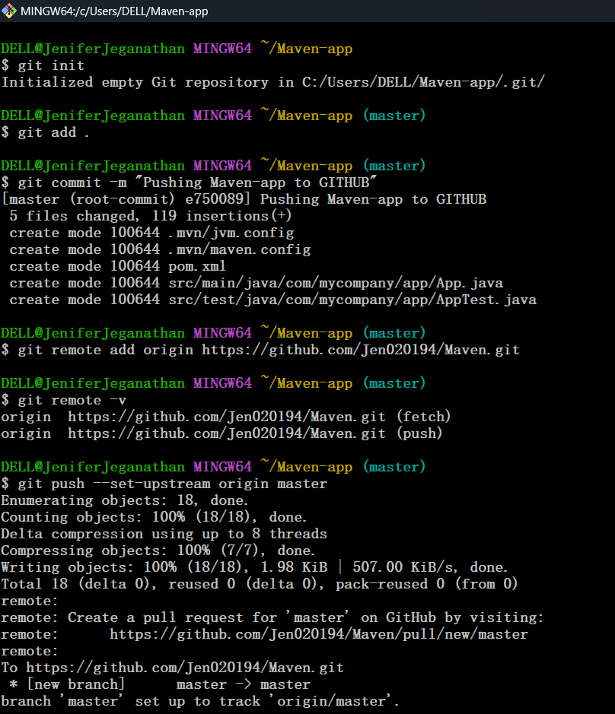

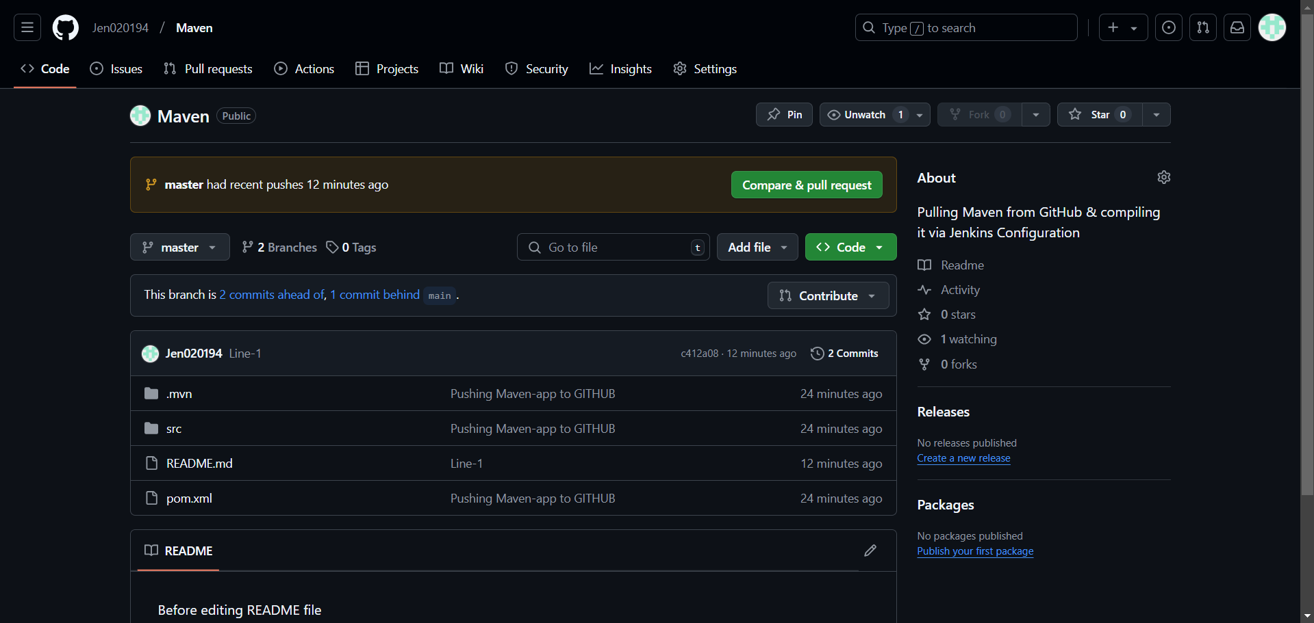

1. **Created a new job in Jenkins named “Maven_Git_PollSCM” & Configured Source Code Management for the job by providing the appropriate Github repository link and branch name**

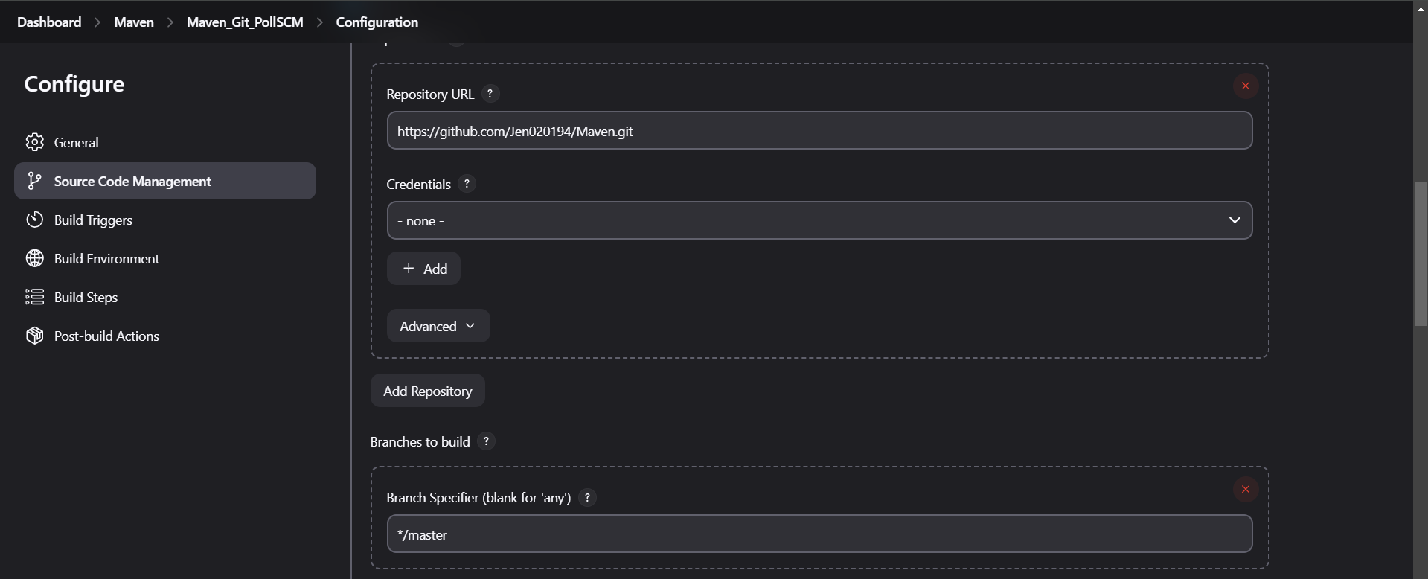

1. **The Poll SCM Build Trigger has selected & the time provided for the build**

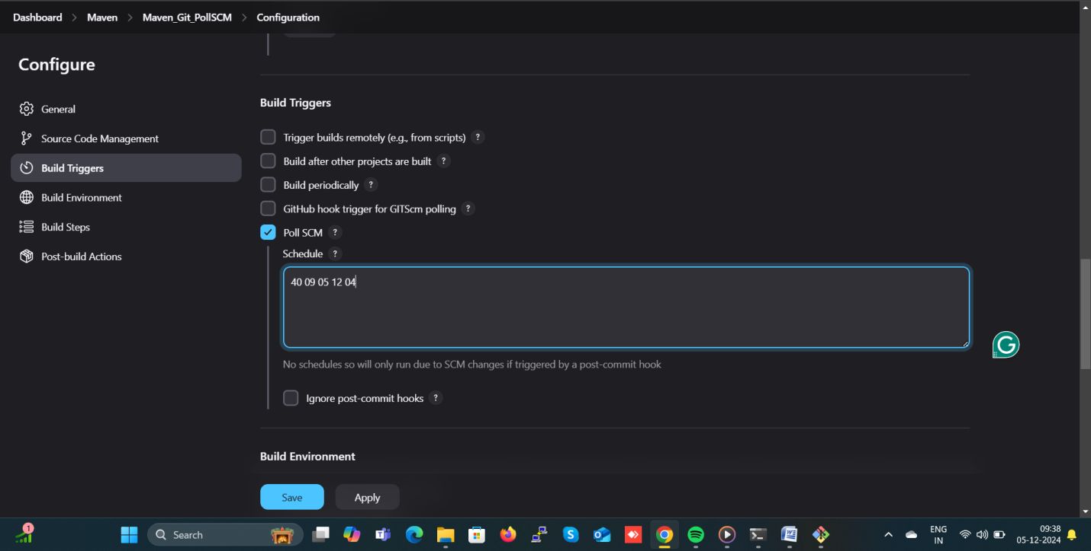

1. **Using “mvn package” command in Execute Windows Batch Command Build Step we can compile the Maven folder & Click on Apply and Save**

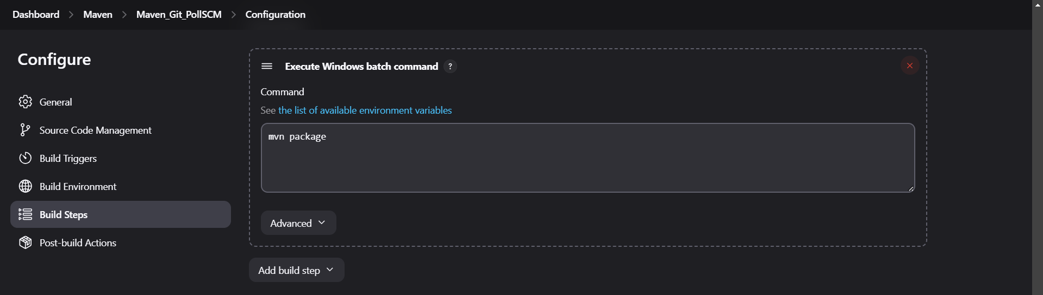

1. **The Console Output**

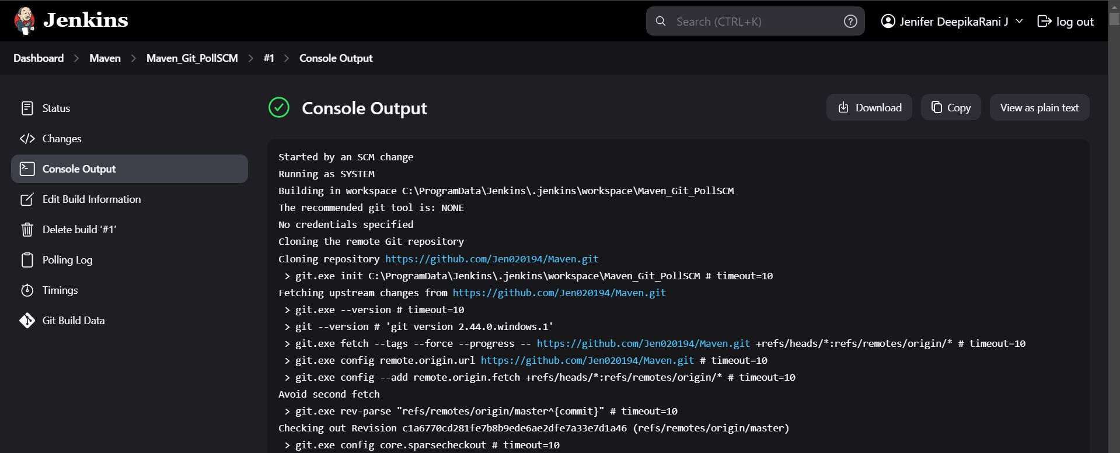

1. **As a result we can get the Target folder in the Jenkins workspace folder in our local repo**

